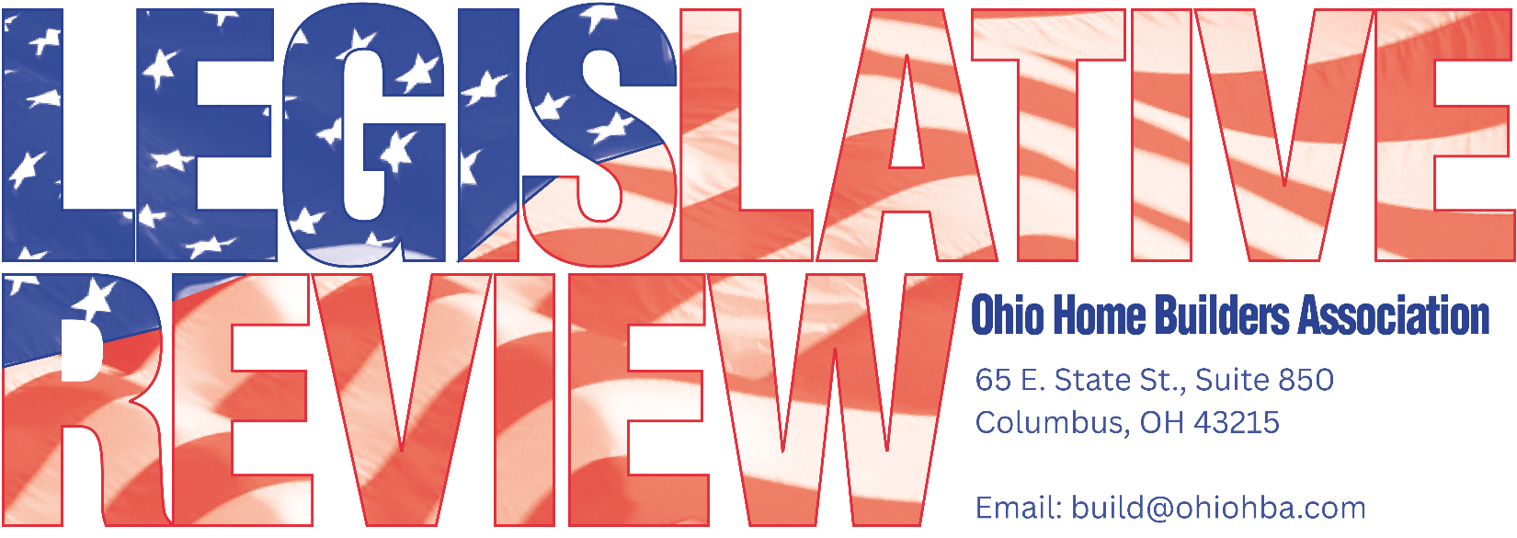
AUGUST 25, 2026
LEGISLATIVE UPDATE – 7

U.S. ARMY CORP ANNOUNCES PLANS TO REALIGN OHIO REGULATORY BOUNDARIES; HUNTINGTON DISTRICT EXPANDED INTO GREAT LAKES AREA
After years of discussions, meetings, letters, and examples provided by OHBA and other stakeholders on the importance of consistency in the regulatory program, the US Army Corp of Engineers (USACE) has officially moved ahead with realignment in Ohio.
Colonel Phillip Valenti, USACE, Huntington District, announced Friday that USACE is preparing to realign Regulatory boundaries to improve consistency, coordination and customer service. Implementation will begin October 1, 2026, and will provide applicants, agencies and other stakeholders with a clearer single-district point of contact. The Huntington District will be the Regulatory contact for the Great Lakes and Ohio River Division’s area in Ohio. The Great Lakes area of the State will no longer fall under the Buffalo District’s jurisdiction.
Updates on Regulatory boundary realignment will be provided at the following link
http://www.lrd.usace.army.mil/wetland-permits/

Please feel free to contact OHBA with any questions or comments 614-228-6647.

SAVE THE DATE OHBA FALL BOARD OF TRUSTEES MEETING

Save the date for OHBA Fall Board of Trustees Meeting on November 17, 2026 at the Hilton Easton in Columbus.

