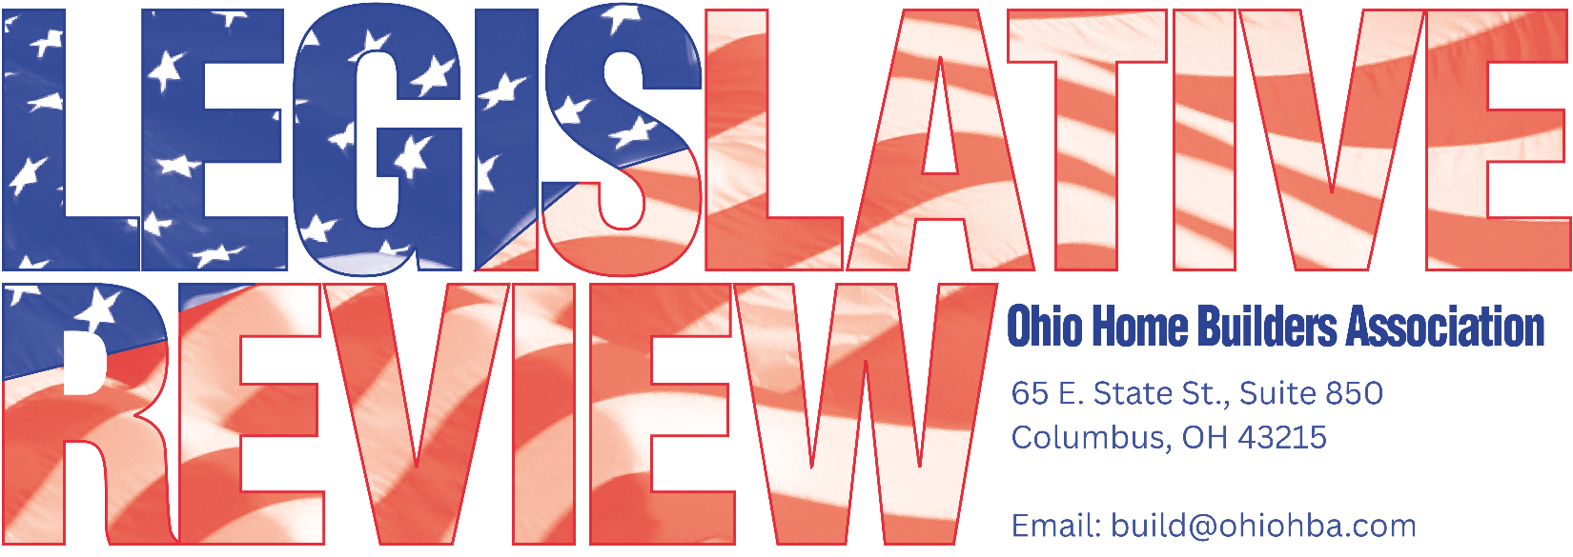
AUGUST 13, 2026
LEGISLATIVE UPDATE – 6

HBA OF GREATER TOLEDO MEMBERS PRESENT CHALLENGES TO OEPA DIRECTOR
OHBA joined several members of the HBA of Greater Toledo in their recent meeting with the OEPA Director, John Logue and his staff to present challenges faced in NW Ohio in the enforcement of Stormwater regulations. Steve Mitchell, Mike White, Brian McCarthy, and Greg Feller prepared examples and provided valuable insight into the cost and impractical application of certain stormwater regulations in areas of NW Ohio. The Director and staff were receptive to such concerns and agreed to continue to review internally potential for guidance or direction to those enforcing the rules in that area of the State. Further, the members of the HBA suggested language for the agency to consider when the Construction General Permit is up for its 5-year rule review. OHBA continues to monitor the rule package and ensure the agency follows up on its internal review of these important issues.

LEGISLATOR INTRODUCES BILL TO DECREASE REFERENDUM SIGNATURE REQUIREMENT
In response to recent activity in Findlay, Rep. Ty Matthews has introduced legislation (HB 985) to decrease the zoning referenda signature requirement from 35% to 20%. As you may recall, OHBA and other supporters were successful in getting the signature requirement increased from 8% to 35%. OHBA has already reached out to stakeholders and the sponsor.

OHBA WORKING ON EXPANDING DEFINITION OF RESIDENTIAL DWELLING AND MAKE CHANGES TO SINGLE STAIR REQUIREMENTS
SB 428 amends building, contractor, sewage, and arbitration laws to extend residential building code coverage to four-family dwellings and align related definitions across multiple sections of the Revised Code. The legislation also authorizes a single stairway exit for certain group R-2 buildings, updates local licensing and fee rules for specialty contractors. The act is named the Build Smart Act. OHBA has reached out to the sponsor (Reynolds) to offer valuable insight into these suggested changes. Members of OHBA have been involved in these code discussions for numerous years and are making suggestions to prepare for the legislature eventual return after the election.

OHBA FILES AMICUS IN SUPPORT OF MINDALE FARMS CO v. CITY OF TALLMADGE IN THE US COURT OF APPEALS FOR THE SIXTH CIRCUIT
After an unfavorable ruling in the Northern District Court, Mindale Farms Co appealed to the Sixth Circuit Court of Appeals on its regulatory takings claim, equal protection claim and declaratory judgment claim based on denial of already established R-6 zoning. As it also did in the Northern District, OHBA has filed a motion for leave to file its amicus in support of Mindale Farms Co. The Court has yet to rule on its motion to determine if it will allow the Amicus in Support.
RCAC TO REVIEW NEC CHANGES AT SEPTEMBER MEETING
The Residential Construction Advisory Committee (RCAC) will review potential amendments to the National Electric Code, including current and proposed AFCI requirements. The meeting is scheduled for Wednesday, September 16th at 9am. Virtual attendance is an option. Contact OHBA if you are interested in attending, in person, or virtually to provide crucial feedback on the impact of these AFCI provisions.

Please feel free to contact OHBA with any questions or comments 614-228-6647.

