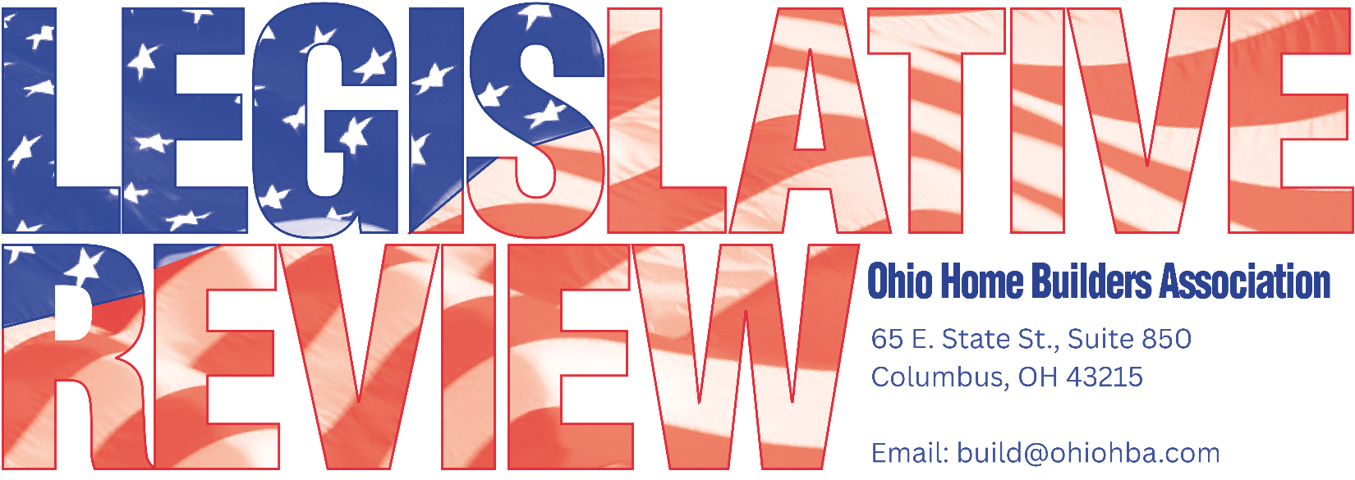
MARCH 31, 2026
LEGISLATIVE UPDATE - 4

Hb 361 awaiting next move
HB 361, OHBA’s top priority, is still awaiting further House Committee action. While Speaker Huffman has expressed his support and desire to move the legislation, there are a few members of the committee and local governments raising objections. OHBA has been told the goal is to get Sub HB 361 on the House Floor in May. If you are interested in calling your State Representative to urge their support of Substitute HB 361, you should do so ASAP. OHBA’s Vince Squillace provided testimony in the most recent hearing reminding the local government committee this is the most important step the state can take to increase housing production in Ohio.
The bill has been labeled the “shot clock” bill as it establishes reasonable time limits for local government to approve applications, if not, the application is approved. The substitute bill analysis has also been attached. We want the House to do its part in removing needless delays and a take a strong move towards increasing housing development in Ohio.
Information on all the members of the House local government committee can be found at the following link https://ohiohouse.gov/committees/local-government

BBS MEMO ON RESIDENTIAL DRAWING REQUIREMENTS

At OHBA’s Spring Board Meeting, BBS Executive Secretary, Regina Hanshaw, referenced a 2006 BBS Memo in response to a question regarding residential building systems descriptions. In response to some confusion regarding the descriptions of residential building systems and what must be submitted for review, the RCAC and BBS distributed the attached memo back in 2006. Similar questions were brought up recently, and this memo may be a good resource. Feel free to contact OHBA with any questions.

