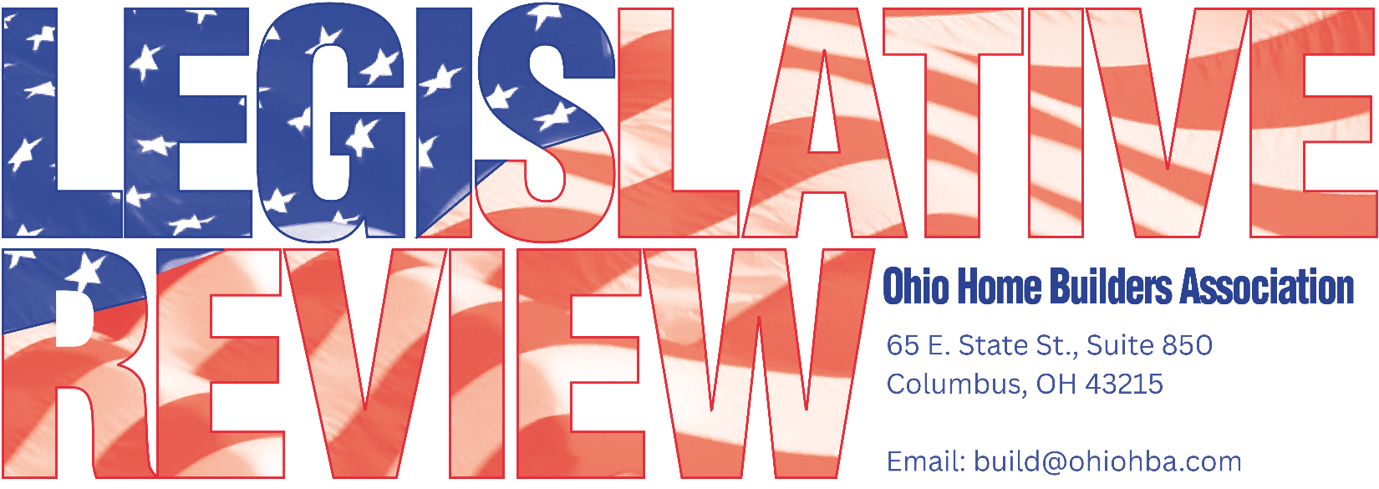

FEBRUARY 17, 2026
LEGISLATIVE UPDATE - #2

E-VERIFY REQUIREMENTS FOR NONRESIDENTIAL CONTRACTORS

Governor DeWine signed HB 246 into law in December requiring nonresidential construction contractors, subcontractors, and labor brokers to use the federal E-Verify system to confirm the identity and work authorization of employees hired for nonresidential projects in Ohio. Employers must retain verification records and are prohibited from continuing to employ workers who receive a final nonconfirmation through E-Verify.

The Attorney General has yet to put out any opinion or rule on implementation and enforcement, so there are still questions to be answered. In the meantime, below is some information on the requirements.
It is OHBA’s understanding that the legislation is supposed to apply to hires, as it is illegal to e-verify existing employees per federal regs (unless it’s a FAR project). The LSC analysis is clear on that, however, the way the language is drafted could be construed otherwise. The commercial contractor groups plan to engage with AG’s office as it’s implemented to ensure that it only applies to new hires. OHBA will continue to stay informed on AG’s plans. Let us know if you have any other questions.
Contractors should begin preparing now to ensure compliance by the effective date.
- Enroll in E-Verify: Complete registration and confirm system access.
- Update Hiring Procedures: Integrate E-Verify into onboarding for covered projects.
- Train Key Staff: Ensure HR and project leaders understand E-Verify and nonconfirmation rules.
- Review Subcontractors: Confirm subcontractors and labor brokers are prepared to comply.
- Assess Risk Areas: Identify gaps in recordkeeping, oversight, and project classification.

Resources
- E-Verify Home Page (USCIS): Overview of the program, eligibility, and system access.
- Enroll in E-Verify: Step-by-step enrollment for employers and hiring sites.
- E-Verify User Manual (Employers): Comprehensive guidance on how to use E-Verify, including timelines and case handling.
- E-Verify Employer Responsibilities: Explains employer obligations, anti-discrimination rules, and proper use.
- E-Verify Employer Resources: Checklists, videos, and other resources to help employers understand their responsibilities and simplify the hiring process.
- E-Verify Online Training (Webinars & Tutorials): Free, on-demand training for HR staff and hiring managers.

Please contact OHBA with any questions 614-228-6647.

SAVE THE DATE

OHBA Spring Organizational Meeting is scheduled for March 25, 2026, at The Athletic Club of Columbus. Detailed information will be e-mailed out soon.

Reminder, OHBA’s new office address is 65 E. State St., Suite 850, Columbus, OH 43215.

