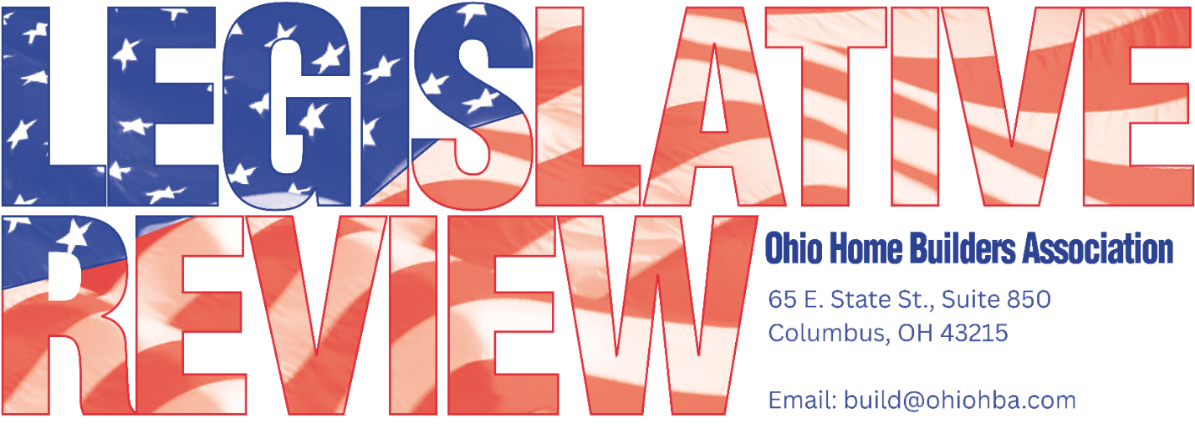
2025 ohba year IN revieW

OHBA RELOCATES TO NEW CAPITOL SQUARE ADDRESS

At the end of 2025, OHBA moved into its new location. OHBA offices have a new address! We are now located at 65 E. State St., Suite 850, Columbus, Ohio, 43215

OHBA INVITED TO TESTIFY BY CHAIRMAN OF HOUSE DEVELOPMENT COMMITTEE

Chairman Representative Jim Hoops invited OHBA Executive Vice President, Vince Squillace, to testify on behalf of OHBA on residential development in Ohio during one of the first meetings of 2025 of the House Development Committee. Vince’s testimony acknowledged the critical shortage of housing, focusing mainly on the lack of developed lots and regulatory burdens inhibiting the supply of more affordable lots.

COMBATING PERMITING BARRIERS/ COMPREHENSIVE PLAN REQUIREMENTS

Continuing into 2026, OHBA worked very closely with sponsors and committee members in 2025 on HB 361 Local Regulation to address permitting challenges in the land development process, as well as, continued to urge a substantive review of comprehensive planning.

INCREASED SIGNATURE REQUIREMENT REFERENDUM PETITIONS FOR LOCAL ZONING PASSED

After advocating over several general assemblies for such an increase, OHBA was successful in working to increase the signature requirement for certain referendum petitions from 15% to 35%.

HB 96 OPERATING BUDGET PASSED WITH VARIOUS HOUSING INITIATIVES

OHBA has been consistently delivering a message on the critical shortage of both developed residential lots, and housing. HB 96 included several housing initiatives including the Residential Development Revolving Loan Program, Residential Economic Development Districts (REDD) and modifications to the Welcome Home Ohio Program.

ENGAGED JOINT COMMITTEE ON AGENCY RULE REVIEW (JCARR) ON RESIDENTIAL BUILDING CODE

OHBA sat down with one of the Chairs of JCARR to better understand the process for any potential challenges to the rule making process. Maintaining the strict review process for the adoption of the Residential Code of Ohio remained a top priority for OHBA.

OHBA REGULATORY RELIEF INCLUDED IN RESIDENTIAL DEVELOPMENT REVOLVING LOAN FUND

The Residential Development Revolving Loan Program (RDRLP) established in the Operating Budget, House Bill 96, will be administered by the Ohio Department of Development (ODOD). The program was designed to remove infrastructure barriers that restrict new single-family housing construction in eligible areas, and includes many suggestions made by OHBA to make regulatory relief a condition of eligibility for funds.

OHBA SERVED ON OHIO CHAMBER OF COMMERCE 2025 HOUSING SUMMIT “CREATING YIMBY IN OHIO” PANEL

The Chamber of Commerce invited OHBA to serve on an important panel at its annual housing summit at the Statehouse on February 20, 2025. OHBA’s Vince Squillace served on the afternoon panel “Creating YIMBY in Ohio”.

OHBA DEFENDS AGAINST ATTACK ON RESIDENTIAL DEVELOPMENT TOOLS

OHBA educated committee members and sponsors of HB 113 and 154 to express concerns over the changes proposed to Type II Annexations and Residential CRAs. OHBA members helped to express the benefits of current CRA and Annexation policies. Further, OHBA educated the legislature on the difference between CRA and TIFs, and importance of such residential development tools.

DAYTON MEMBER, ROBI SIMMS, SHARED BENEFITS OF COMMUNITY REINVESTMENT AREAS(CRA)

In response to legislation attempting to change the role of school boards in residential CRA approvals, OHBA member, Robi Simms, offered excellent, persuasive testimony on successful affordable housing developments in the Dayton area using CRAs, and the potential negative impacts the legislation would have on the more affordable market.

AMICUS CURIAE BRIEF SUBMITTED IN TALLMDGE, OHIO ZONING CASE

OHBA and NAHB filed briefs with the Northern District in a case coming out of the Tallmadge, Ohio challenging R-6 zoning application denial by City Council as arbitrary and an abuse of its police power after staff report determined compliance with the comprehensive plan and all objective standards.

OHBA MEMBERS TESTIFIED ON PROPOSED UPDATED WOTUS DEFINITION

OHBA members participated in listening sessions providing feedback to the US EPA and US Army Corps of Engineers in its development of updated ‘waters of the us’ definition. The rule will provide builders with much-needed clarity by defining which waters are subject to federal jurisdiction under the Clean Water Act while continuing to protect our nation’s vital waterways.

CONNECTED LUCAS COUNTY MEMBERS WITH EXPERTS ON MS4 ISSUES

In response to concerns raised on enforcement of NPDES provisions in the Northwestern area of Ohio, OHBA connected with developers and local government officials to help navigate potential solutions to remedy apparent bias against residential development.

OFFERED SUPPORT FOR PROPOSED SUBMETERING LEGISLATION

OHBA submitted testimony and participated in numerous proponent meetings on legislation clarifying the rights of property owners to choose energy services within the boundaries of their properties. House Bill 173 presents a clear definition of a public utility while respecting and recognizing the PUCO’s authority thus protecting property owners’ rights in Ohio.

OHBA MET WITH OHIO WATER DEVELOPMENT AUTHORITY

OHBA met with Director Fraizer to discuss addressing capacity issues and how water/sewer impacts future development. Both Ohio Department of Development and Water Development Authority provide funding for infrastructure and OHBA was able to provide valuable insight into residential development needs.

MONITORED ADDITIONAL PROPOSED CHANGES TO EXCAVATION 811 LEGISLATION

Another round of proposed changes to the Call Before You Dig law had hearings in 2025 and OHBA monitored any impacts to those participating in 811. OHBA continued to advocate for timeliness of marking by utilities and reasonable training requirements.

OHBA MONITORED APPLICATIONS FOR STREAMLINED RESIDENTIAL DEVELOPMENT PROPERTY TAX EXEMPTION PROCESS

After successfully getting changes in the law enacted to exempt the increase in value of residential development property until the lot is sold or construction begins, OHBA urged members to report on the streamlined application process. OHBA heard from numerous applicants around the State.

TECHNICAL FEASIBILITY OF ARC FAULT PROVISIONS CHALLENGED

With the most recent adoption of the 2023 NEC and expansion in prior versions of the NEC, OHBA urged members having any issues with Arc fault and Dual function breakers across multi-family and single-family business to send along to the Residential Construction Advisory Committee (RCAC) and OHBA for consideration. One of the statutory requirements for the review of any code change is ‘technical feasibility’ giving OHBA an avenue to challenge based in the revised code. Further advocacy by OHBA and review of expansion of Arc Fault exemptions will continue into 2026.

OHBA JOINED IN EFFORTS TO ADDRESS ISSUES WITH BUFFALO DISTRICT
OHBA again joined continued efforts urging action to address issues with the Army Corp of Engineers Buffalo District. Industry groups and numerous members of the Ohio Congressional Delegation signed on in support of consolidating Ohio under one district to combat ongoing issues.
ANNUAL MEETING WITH BUREAU OF WORKERS COMPENSATION ASSOCIATION REPRESENTATIVE

OHBA held its required meeting with the BWC Association representative on its group rating program, as well as, all other products and services offered by the Bureau.

OHBA CONTINUED STRONG REPRESENTATION ON BUILDING CODE BOARDS
Both the Residential Construction Advisory Committee (RCAC) and Board of Building Standards (BBS) include active members of OHBA engaging in the code review and adoption process. Maintaining a reasonable residential building code for Ohio is a top priority for OHBA. This goal is constantly being threatened by more stringent codes being proposed at the National level. Both the IECC and NEC are two recent examples. Fortunately, the Residential Construction Advisory Committee is statutorily required to perform a thorough review of these codes including cost impact and technical feasibility. The members of the RCAC and BBS play a crucial role in keeping Ohio’s code reasonable.
CONTINUED ENGAGEMENT WITH UTILITY PARTNERS
Throughout the year, OHBA met with numerous utilities, both gas and electric, to engage the groups on potential development standards or ways to provide more consistent expectations. Additionally, OHBA explored apparent issues with gas capacity in certain areas of Ohio.
SKILLSUSA OHIO TEAMWORKS SPONSORSHIP AND PARTICIPATION

OHBA continued to be the main sponsor for the SkillsUSA Teamworks competition which brought an impressive turnout of young men and women competing in the various construction trades. Several OHBA past presidents served as judges and volunteered throughout the competition.

REVIEW AND ADOPTION OF MINIMUM QUANTIFIABLE STANDARDS UPDATES

As the adopting body of the workmanlike standards for the industry, OHBA reviewed and adopted the Eighth Edition of the Minimum Quantifiable Standards.

CONTINUING AGENCY AND LEGISLATIVE FOLLOW UP

While agency issues are always ongoing, many of the legislative issues from 2025 will likely continue into the new year. Throughout the year, OHBA received questions from around the state on enforcement of multiple regulations, including, but not limited to utility, environmental and building code issues. OHBA provided valuable insight and contacts to help mitigate issues brought to OHBA’s attention.

OTHER MONITORED LEGISLATION

HB 203 Construction Projects; HB 246 Employee Verification; HB 288 Wages; HB 427 Demand Response; HB 568 Retainage; SB 6 Building Inspections; SB 54 Construction Contractors; SB 125 Roofing Licensure

